These instructions will explain to you how to manually create map data for genji parkour. This will involve manually writing down codes and pasting things in a special template.

# Step 1:

Load the data tool with code **QR1PZ** on the desired map.

# step 2:

Write down the vectors of the checkpoints and orbs you want on your maps. You should also write down which orbs you want and what they do. And kill orbs if you want those.

notes:

* You can still make more orbs per checkpoint, just not inside the tool. You will have to manually write the orb positions down one by one.
* Remember you can’t place orbs/dashes etc on cp 0 still

# Step 3:

Open the template document in notepad or another text editor.

Put in your map data in the “rule("Map Data <---- INSERT YOUR MAP DATA HERE")” rule.

Note that the capitalization is important. If you put “true” instead of “True” it won’t work. Spaces and don’t matter.

Things in “quotes” are comments. You don’t need to change or remove them.

The expected input and format is displayed is displayed in the comments. Note that vectors are (X,Y,Z) co-ordinates and Y is the height.

If you have multiple entries, you should put the comma ( , ) symbol at the end of each except the last entry.

Make sure you fill in all the variables. For example even if you want the first orb to not give ultimate, you still have to fill in False in the ultimate rule for it to work properly.

**Checkpoints**: Positions  
**Killball**: Position, Radius, Checkpoint  
**Orb**: Position, Checkpoint, Strength, Ultimate, Dash, Lock

If you don’t want to use any kill spheres or orbs, remove the related variables from the data rule.

*(example of me creating 3 orbs for my test map)*

## Optional step: addons

To enable addons you have to scroll down to the addon rule.

Remove the “disabled” at the start of the related rules.

Fill in the data as you would normally do.

In this example I add dash to checkpoint 5 and 6.

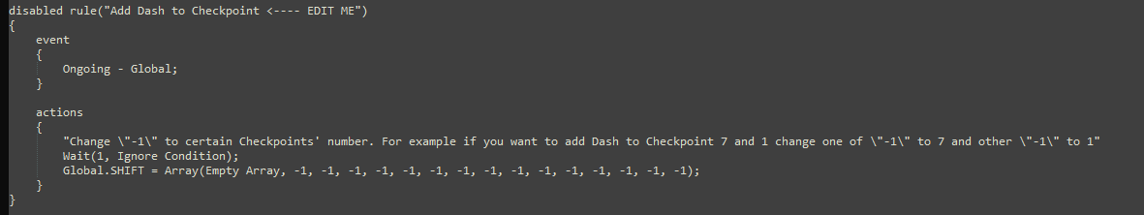

# Step 4:

Copy the ENTIRE code and paste it back ingame.

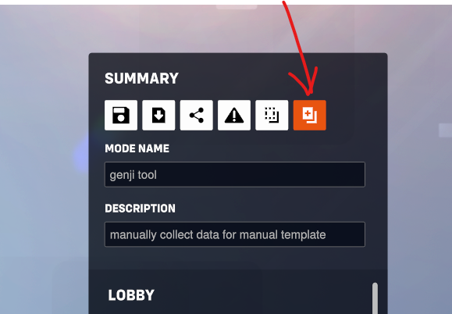

# Step 5:

Select het map in the settings and test the map.

# Step 6:

Save the code as you would normally do with the share button.